**EXPERIMENT:2** Create a simple cloud software application for Property Buying & Rental process (In Chennai city) using any Cloud Service Provider to demonstrate SaaS include the necessary fields such as Buy, Rent, commercial, Rental Agreement , Rental Agreement, Area, place, Range, property value etc.

**AIM:** To Create a simple cloud software application for Property Buying & Rental process (In Chennai city) using any Cloud Service Provider to demonstrate SaaS

**PROCEDURE**:

**step1**: Go to zoho.com.

**step 2**: Log into the zoho.com.

**step 3**: Select one application step.

**step4:** Enter application name as property buying & rental.

**step 5:** Created new application as property buying & rental.

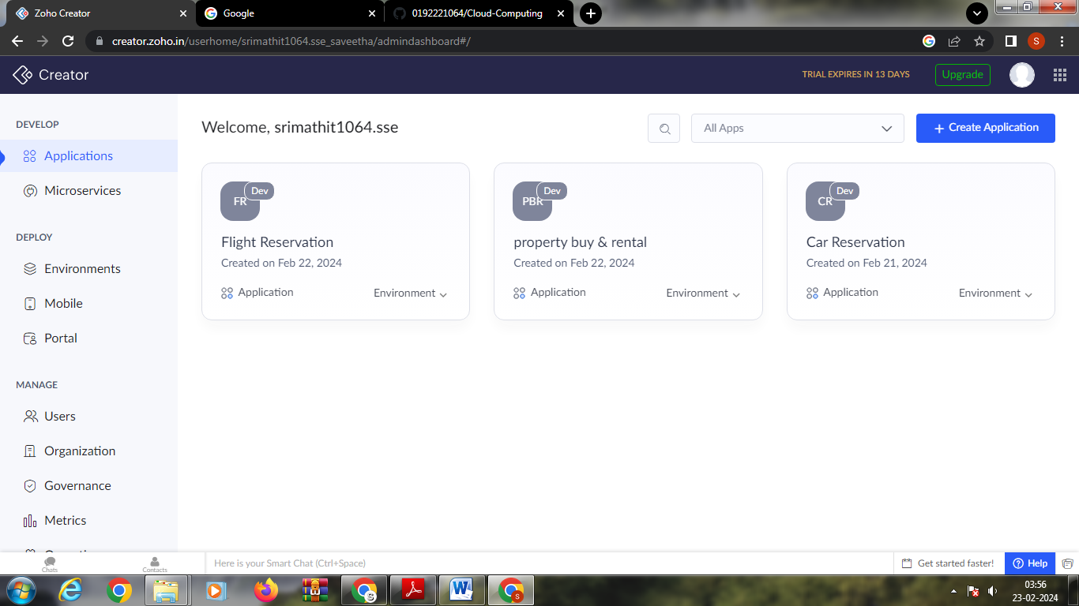

**Step 6:** create login page form

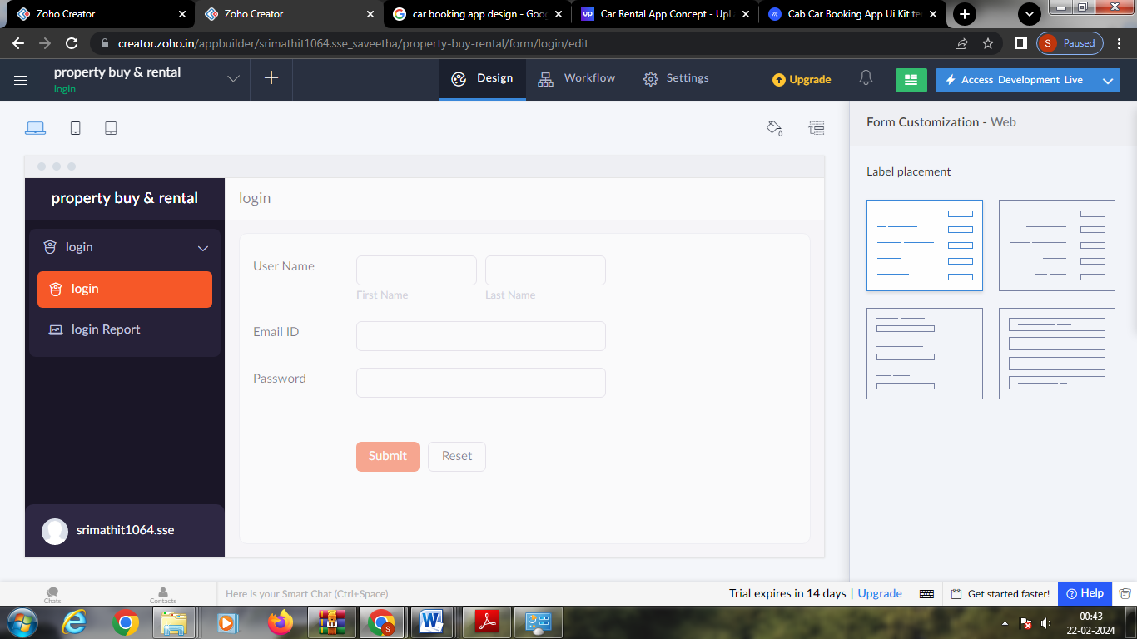

**Step 7:**Create a second form for property andRental details

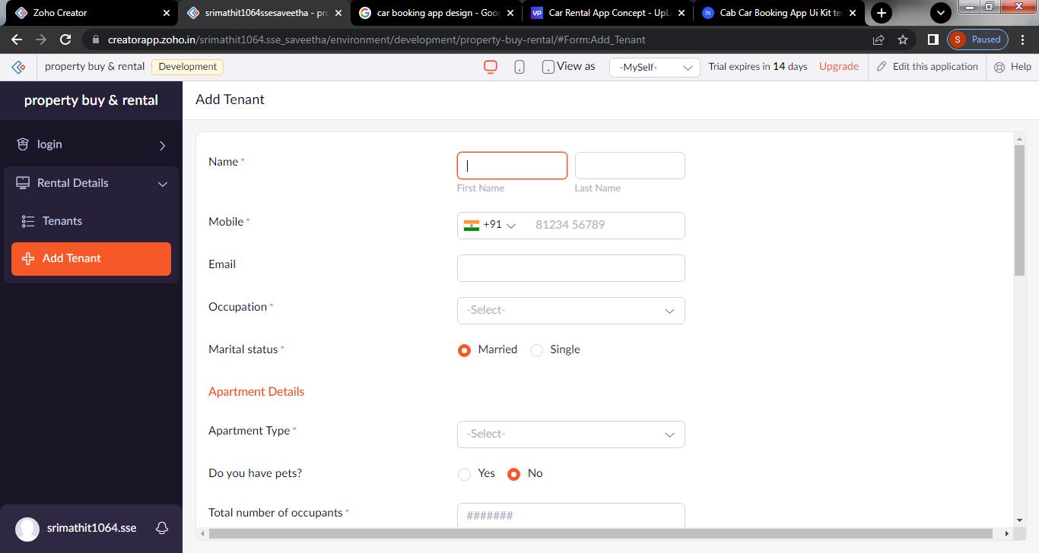

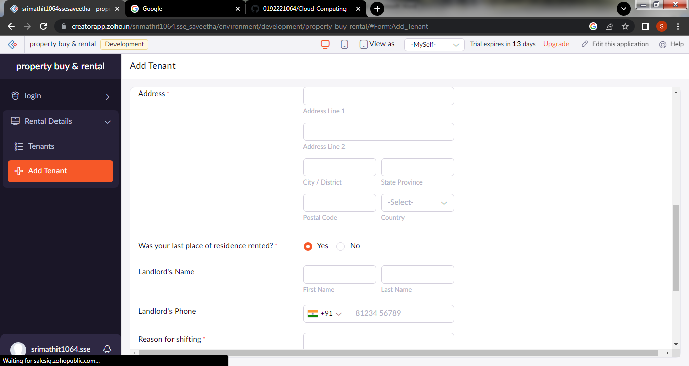

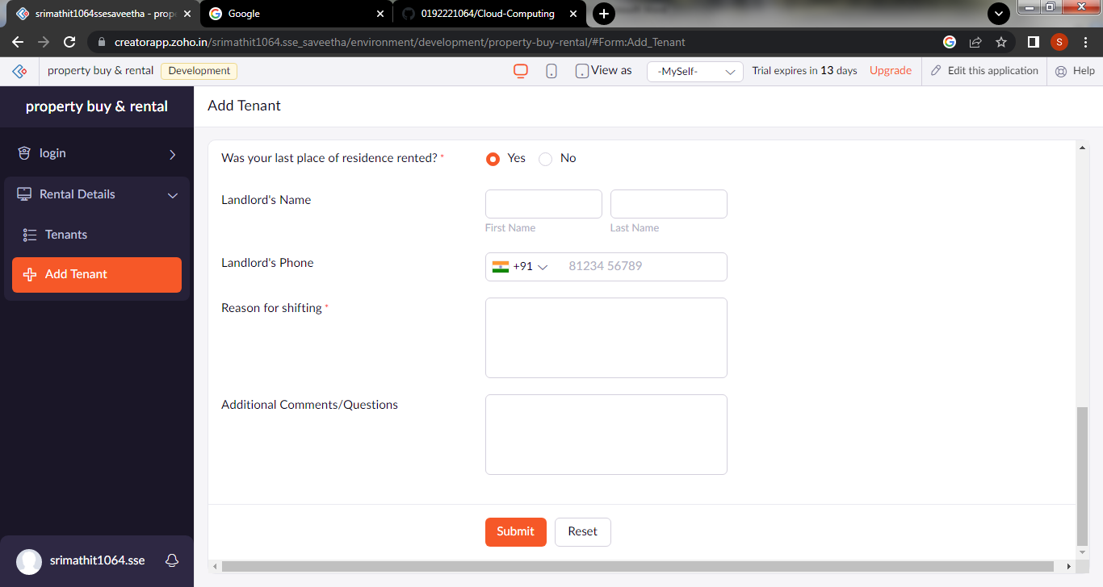

**Step 8:**create a third form for property agreement

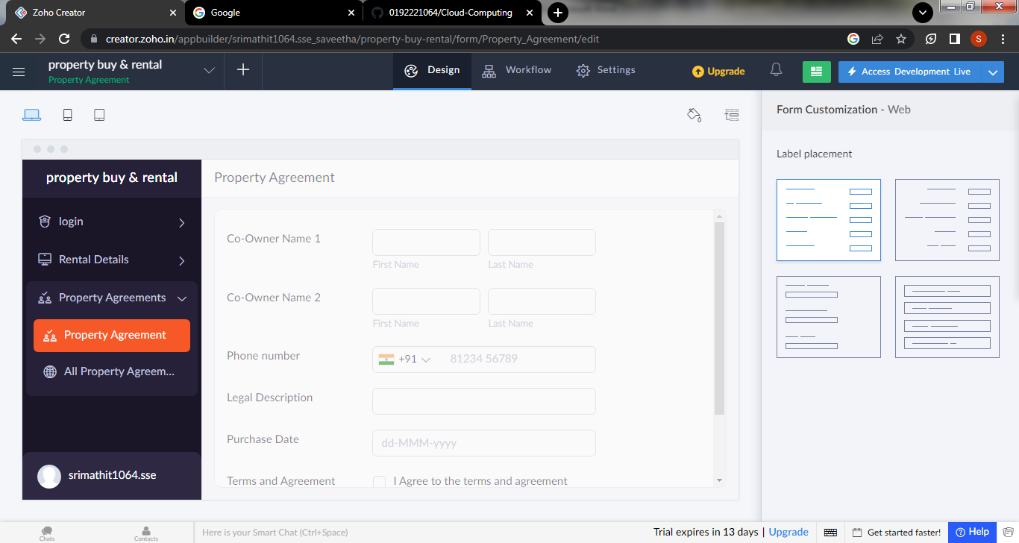

**Step 9:** create a fourth form for rental history verification

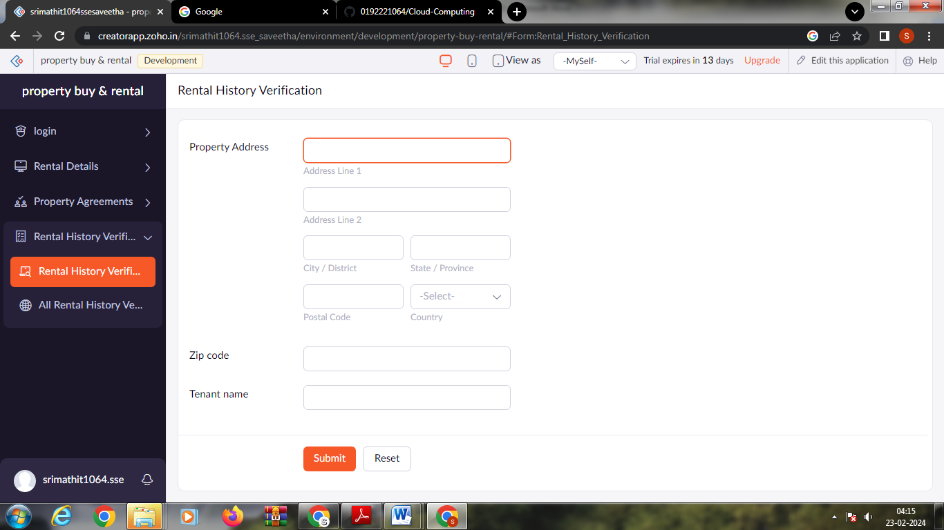

Step 9: click the access development to see the output

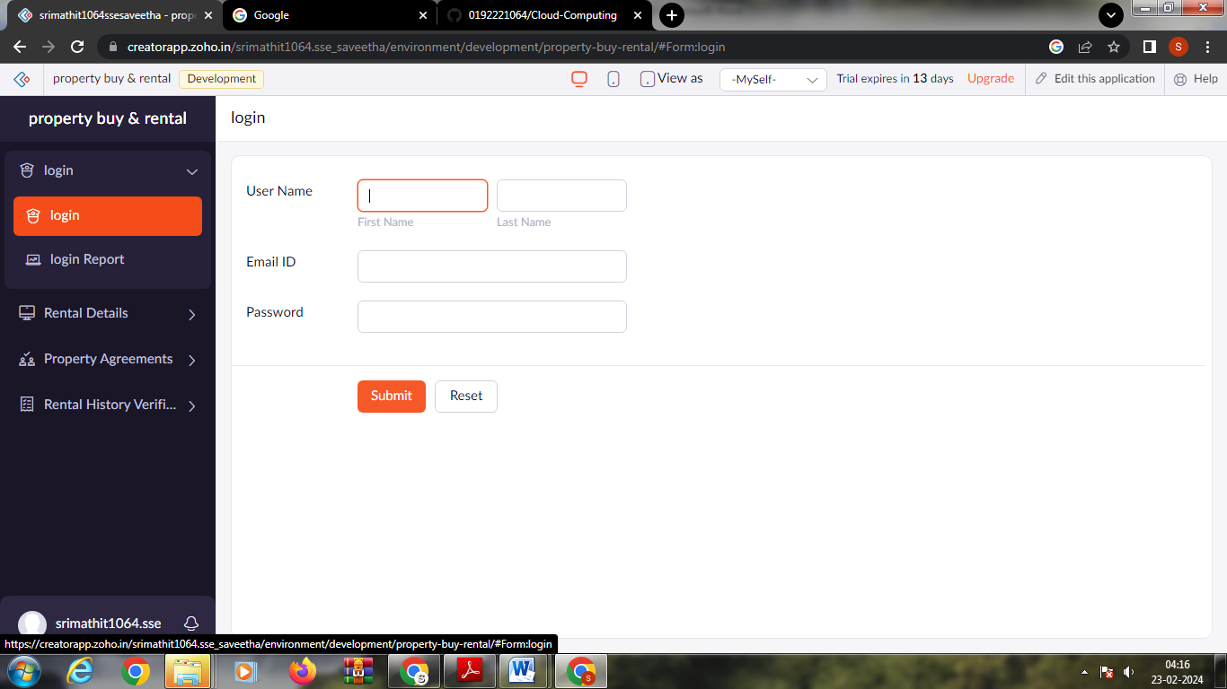

Step 10: click the report to see the stored data

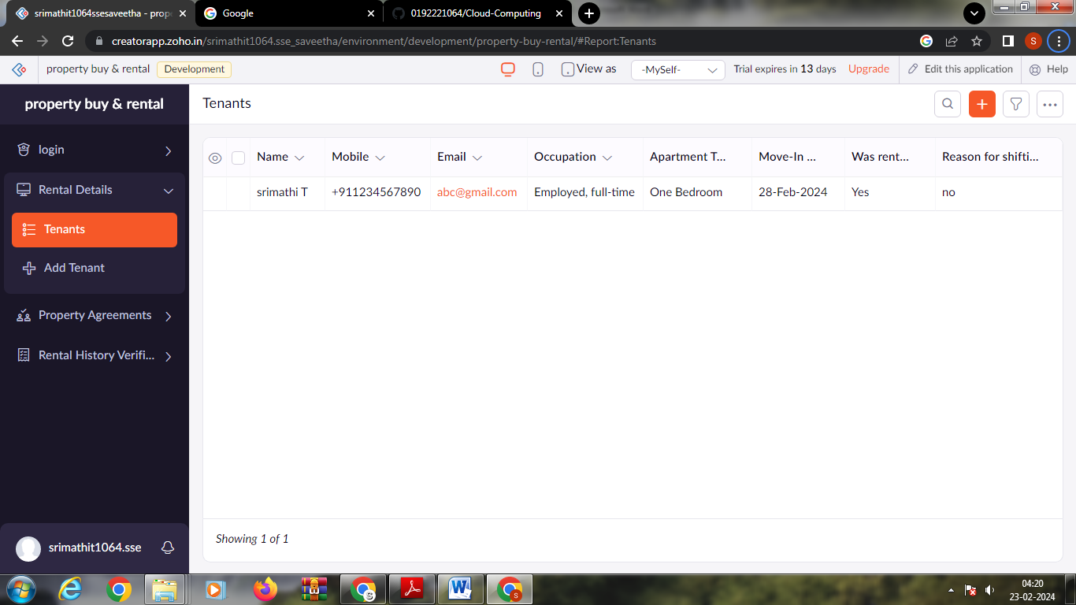

Step 11: click on the mobile icon to see the output in mobile format

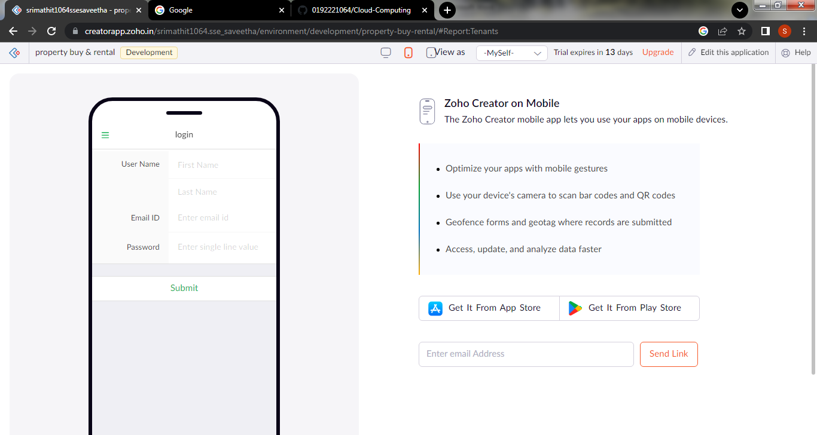

Step 12: click on the tablet view to see the output in tablet form

